Specification

Ideas

Idea 1 is my minimum specification.

Idea 1
- A plan view of a 2-D single black rectangular room with fixed height and width.
- 2-D single white ball of fixed diameter, with fixed:
  - initial starting position
  - Initial direction
  - Velocity (step size)
  - kinetic energy

Idea 2
- A plan view of a 2-D single textured and coloured rectangular room with fixed height and width.
- Multiple 2-D textured and coloured balls with:
  - variable initial starting position
  - variable velocity (step size), velocity increases when bouncing off a surface.
  - fixed initial direction
  - fixed diameter
  - variable kinetic energy

I aim to complete a program that utilises Ideas 1 and 2. If everything goes well I hope to include the additional options mentioned in Idea 3.

Idea 3
    - A plan view of a single 2-D textured and coloured rectangular room with variable height and width.
    - Multiple 2-D textured and coloured balls of fixed diameter, variable initial direction and kinetic energy.
- Two variable size 2-D textured and coloured paddles, one at either end of the room.

User Interface

The interface will be implemented using the java awt (abstract windowing toolkit).

The user interface for the initial program will be minimal. The user will just see a white ball moving over a black rectangular shape background, all this will be contained within a Java Applet. The bouncing ball will freeze when the space bar is pressed.

Once the minimum spec’ program is up and running, the next step will be to implement a basic UI. By means of a user interface the user will be able see:

  - A coloured and textured ball moving over a coloured and textured background.
  - Start/Reset, Pause/Resume radio buttons.

The user will be asked to input the initial velocity into a field (must be an integer) before the simulation is begun.

If everything goes according to plan the “Pong” program will be implemented. By means of a user interface the user will also be able to:
- vary the size of the paddles
- vary the difficulty of the computer player

The implementation will look very similar to that of Idea2 but with 2 extra coloured and textured paddles. Because Idea 3 is an extension the user interface has not be contemplated.

Design

The following design is specified for Ideas 1 & 2.

What Should Be Built

Three main objects

Ball - Attributes
Colour
Size
Velocity(StepSize)
Direction
Initial, Current & Next state

Room - Attributes
Colour
Size
Shape

Bouncing Ball (Interface) - Attributes
Size
Layout
Colour
Interaction

How it’ll Be Built

Ball()

The whole program could be constructed using one class. However this would affect the generality of the program as a whole. If more balls were to be added to the program at a later date then a great deal of code would need to be repeated. Having a separate Ball() object simplifies the multiple bouncing ball program.

The Ball() object will have a small number of methods. The Ball constructor will initialise characteristics such as:

- Colour
- Size
- Velocity (StepSize)
- Initial, Current & Next state

The x and y coordinates of the Ball() object will initially be supplied when it is instantiated in the Class BouncingBall().

The Ball() objects next step will be updated by a method called progress(). Progress will calculate whether or not the ball has hit a wall surface.

The paint() method will simply define the shape and colour of the Ball() object.

BouncingBall()

The room and the bouncing ball interface will be amalgamated into one class called BouncingBall() because there will only need to be one instance of an interface and room. The room will just be the background to the applet. This will be the most complex class; it will extend the Applet class and implement runnable. So for the sake of completeness here are the methods taken from those two classes:

- Init()
- Run()
- Paint()

The init() method is taken from the Applet() class, it is called once when the browser or applet viewer loads the applet. It will be used to initialise the thread, background, graphics and any applet dimensional attributes.

The run() method is also taken from the Applet() class, it will simply cause the thread to sleep for a given number of milliseconds. The time the thread sleeps for will determine how fast the animation sequence will run.

The paint() method is called every time the surface of the applet needs to be repainted. It will be used to update the ball and interface’s graphics.

Notes

The complete scene will be updated in one fall swoop in the higher level class BouncingBall().

The animation will be produced by refreshing all the graphical components on the screen at once. The ball may flicker due to there being no ball graphic present during the ball sleep time. This will be overcome by using double buffering techniques, where a drawing of the current image (present in the background) is shown on the screen whilst the next graphics are being prepared.

The velocities of each Ball() object will be represented using instance variables xVelocity and yVelocity, these are simply added to the present position to calculate the Ball() objects next position.
What I’ve Learnt

Applets inherit a great deal of functionality from the Applet class, ranging from communication with the browser to the ability to present a graphical user interface (GUI).

e.g.

public class HelloWorld extends Applet
{
}

The extends keyword indicates that HelloWorld is a subclass of the class whose name follows: Applet

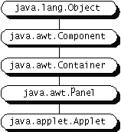

From many of the Bouncing Ball programs I’ve encountered each java Applet requires a minimum of 3 main methods:

Init()

To initialize the applet each time it's loaded (or reloaded).

Run() // associated with threads

Paint()

The basic display method. Many applets implement the paint method to draw the applet's representation within a browser page.

//The below method is not included in the programs I’ve seen but supposedly it
//is used to improve drawing performance

Update()

A method you can use along with paint to improve drawing performance.
To react to an event, an applet must override either the appropriate event-specific method or the handleEvent method. For example, adding the following code to an applet called the Simple makes it respond to mouse clicks.
import java.awt.Event;
. . .
public boolean mouseDown(Event event, int x, int y) {
addItem("click!... ");
return true;
}

This Paint interface defines how color patterns can be generated for graphics operations.

Prototyping

Prototype 1 – Graphics Example

import java.applet.Applet;
import java.awt.*;

public class Car extends Applet
{
public void paint(Graphics g)
{
Graphics2D g2 = (Graphics2D)g;

// 1 ball and 2 paddles
Ellipse2D.Double ball = new Ellipse2D.Double(240, 240, 10, 10);
Rectangle leftPaddle = new Rectangle(10, 200, 10, 50);
Rectangle rightPaddle = new Rectangle(480, 200, 10, 50);

// set the color to be used to red, draw and fill ball
g2.setColor(Color.red);
g2.fill(ball);

// set the color to be used to red, draw and fill paddle
g2.setColor(Color.blue);
g2.fill(leftPaddle);

// set the color to be used to red, draw and fill ball
g2.setColor(Color.blue);
g2.fill(rightPaddle);

// create title text at the top of the screen
final int theSize = 20;
String message = "Bouncing Ball";
Font theFont = new Font("Dialog", Font.BOLD, theSize);
g2.setColor(Color.black);
g2.setFont(theFont);
g2.drawString(message, 200, 20);
}
}

The above code produces a graphic representation of an applet with a ball(an ellipse), two paddles(rectangles) and a line of title text. I created this code because these simple graphical ideas will need to be incorporated into Ideas 1,2 and 3.

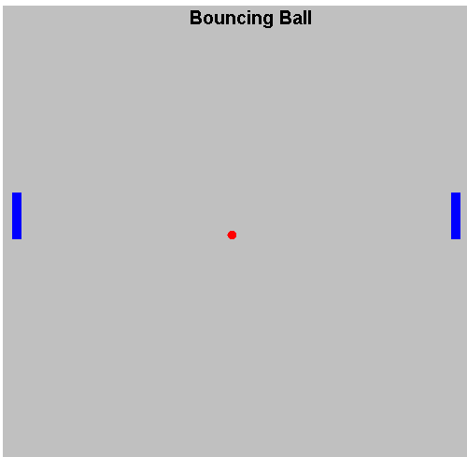

Figure: Output from Prototype1

Prototype 2 – GUI Example

import java.applet.Applet;
import java.awt.Graphics;
import java.awt.Event;

public class Simple extends Applet
{
StringBuffer buffer;

public void init()
{
buffer = new StringBuffer();
addItem("initializing... ");
}

public void start() {
addItem("starting... ");
}

public void stop() {
addItem("stopping... ");
}

public void destroy() {
addItem("preparing for unloading...");
}

void addItem(String newWord) {
System.out.println(newWord);
buffer.append(newWord);
repaint();
}

public void paint(Graphics g)
{
//Draw a Rectangle around the applet's display area.
g.drawRect(0, 0, size().width -1, size().height -1);

//Draw the current string inside the rectangle.
g.drawString(buffer.toString(), 5, 15);
}

public boolean mouseDown(Event event, int x, int y)
{
addItem("click!... ");
return true;
}
}
Prototype 2 takes a step towards implementing a mouse event handler, it is taken straight from the Java 2 essentials book. Whenever the mouse is clicked inside the greyed box a string appears, the greyed box outputs information regarding the state of the Applet. This was created to give me a flavour of the processes undertaken in the Applet generation and also to gain knowledge of event handling using a user interface.
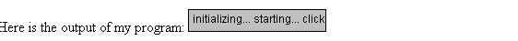 Figure: Output from Prototype2

Prototype 3 – Simple Bouncing Ball Example

import java.applet.*;
import java.awt.*;
import java.net.*;

public class Anim1 extends Applet implements Runnable
{
int x_pos = 0;
int y_pos = 0;
int radius = 5;
int x_velocity = 10;
int y_velocity = 20;

public void init()
{
setBackground (Color.white);
}

public void start()
{
Thread fred = new Thread(this);
fred.start();
}

public void stop()
{
}

public void destroy()
{
}

public void run()
{
while(true)
{
x_pos += x_velocity;
y_pos += y_velocity;

if (x_pos > 500 || x_pos < 0)
{
x_velocity *= -1;
}

if (y_pos > 500 || y_pos < 0)
{
y_velocity *= -1;
}

repaint();
try
{
Thread.sleep(50);
}
catch(InterruptedException ex)
{
// do nothing
}
}
}

public void paint(Graphics g)
{

g.setColor(Color.black);
g.fillOval(x_pos-radius, y_pos-radius, 2*radius,
2*radius);
}

}

Prototype3 is a simple bouncing ball example. The code is a manipulation of that found from a website referenced on the last page. This prototype was created to give me an understanding of the process involved in creating a basic bouncing ball program, and how the code compared to that of the previous prototypes. The program implements runnable, this allows simple creation of the thread. The thread is only created once and run in an infinite loop. In this loop the program takes the limit of the rooms dimensions compares them against the position of the ball. If the ball lies outside those limits then the step size is reversed (dependant on which face is hit). Once the next move has been calculated the paint method is called indirectly and the next frame is drawn using the new positional co-ordinates. The thread sleep method is used to pause the progress of the thread, it takes an integer value (in milliseconds) corresponding to the refresh rate of the on screen graphics.

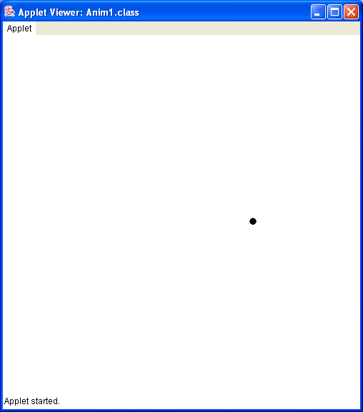
Figure: Output from Prototype3

Resources

- Computing Concepts with Java2 Essentials – Horstmann

- Creating a GUI with JFC/Swing - http://java.sun.com/docs/books/tutorial/uiswing/index.html

- Creating an Animation Loop with Timer -http://java.sun.com/docs/books/tutorial/uiswing/painting/animLoop.html

- Threads - http://java.sun.com/docs/books/tutorial/essential/threads/index.html

- Writing Applets - http://java.sun.com/docs/books/tutorial/applet/index.html

- Bouncing Ball Applet - http://216.239.33.100/search?q=cache:rEJAZ5hSWO0C:www.cs.tcd.ie/David.Eadie/assignments/Assignment1_Maths.doc+java+application+bouncing+ball&hl=en&ie=UTF-8

- Bouncing Ball Applet2 - http://216.239.33.100/search?q=cache:oSSa62BXB58C:www.cs.tcd.ie/David.Eadie/assignments/Assignment1_Engineers.doc+java+application+bouncing+ball&hl=en&ie=UTF-8

- Bouncing Ball Applet 3 - http://venus.cs.depaul.edu/se450/Examples/BouncingBall3a/BouncingBall3aDemo.html

- Examples of Java Applets - http://people.cs.uchicago.edu/~stefanko/Teaching/CS102-Sum2001/Applets/Applets.html

- Java Applet Tutorial - http://javaboutique.internet.com/tutorials/Java_Game_Programming/index.html

- Java Pong Applet - http://www.cjas.org/~smoo/progs.htm

